**Practical No. 01**

**Code:**

import pandas as pd  
  
# Read data into Python  
  
education = pd.read_csv("D:\Desktop files\DESKTOP DEC 2021\Basi Statistics_v3\education.csv")   
  
type(education)  
[education.info](http://education.info/)()  
  
# C:\Users\education.csv - this is windows default file path with a '\'  
# C:\\Users\\education.csv - change it to '\\' to make it work in Python  
  
# Exploratory Data Analysis  
# Measures of Central Tendency / First moment business decision  
education.workex.mean()

education.gmat.mean() # '.' is used to refer to the variables within object  
education.workex.median()  
education.workex.mode()  
max(education.workex)  
min(education.workex)  
max(education.gmat)  
min(education.gmat)  
r = max(education .workex)-min (education .workex)  
print(r)  
  
# pip install numpy  
from scipy import stats  
stats.mode(education.workex)  
  
# Measures of Dispersion / Second moment business decision  
education.workex.var() # variance  
education.workex.std() # standard deviation  
education.gmat.var()  
education.gmat.std()  
range = max(education.workex) - min(education.workex) # range  
range  
y=min(education.workex)  
print(y)  
x=max(education.workex)  
print(x)  
# Third moment business decision  
education.workex.skew()  
education.gmat.skew()  
  
# Fourth moment business decision  
education.workex.kurt()  
  
# Data Visualization  
import matplotlib.pyplot as plt  
import numpy as np  
  
education.shape  
  
plt.bar(height = education.gmat, x = np.arange(1, 774, 1)) # initializing the parameter  
  
plt.hist(education.gmat) #histogram  
plt.hist(education.workex)  
plt.hist(education.workex, color='red')  
  
help(plt.hist)  
  
plt.boxplot(education.gmat) #boxplot  
  
help(plt.boxplot)

**Outputs:**

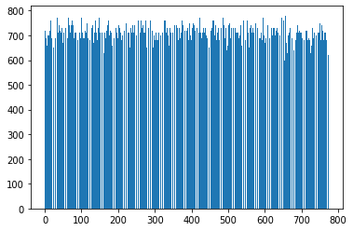

**Bar graph for Gmat Scores**

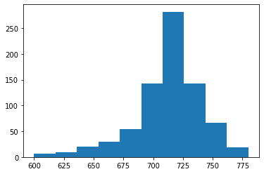

**Histogram for Gmat Scores**

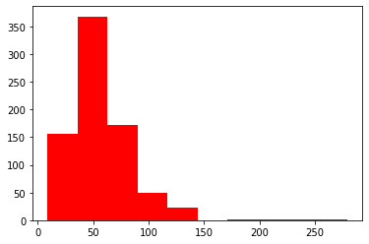

**Histogram for Workex**

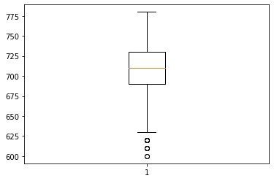

**Box-Plot for Gmat Scores**